K1 SSB mod. performance test.

20 m measurements:
USB mode, 1KHz tone to input mike, output 5 watts
Higher spurious: -50dBc @ 11 MHz
II armonic: -53 dBc
III armonic: -63 dBc

Carrier suppression: -36 dBc

Power @ freq.:
KHz | SSB Watts | CW Watts
14.000 | 4.6 | 3
14.050 | 5 | 3.5
14.075 |  | 3.7
14.100 | 5.2 | 3.7
14.150 | 5.3
14.200 | 5.2
14.250 | 5.1

40 m measurements:

LSB mode, 1KHz tone to input mike, output 5 W
Higher spurious: -48dBc @ 4MHz
II armonic: -51dBc
III armonic: -58 dBc

Carrier suppression: -36 dBc

Power @ freq.:

KHz | SSB Watts | CW Watts
7000 | 4.9 | 4.2
7050 | 4.9 | 4.5
7100 | 4.8
7150 | 4.6
7200 | 4.4
7250 | 4.2

I am not able to measure SSB side-band suppression because my Analyzer (Advantest TR4131) has a minimum Freq. Span of 100 KHz.
The SSB side suppression can be evaluated from SSB Filter shape in the following plot.

RX filter shape:

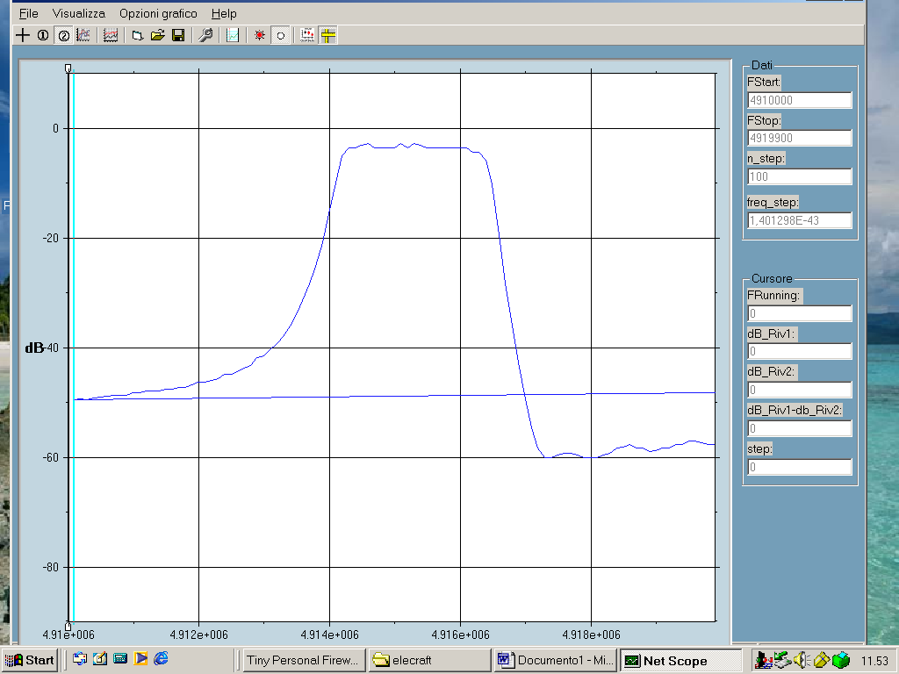

This filter is made with 6 x 4915 KHz crystal.
BFO Freq. Positions are:
20 m USB: 4916.8 KHz
40m LSB :4913.8 KHz

TX filter shape:

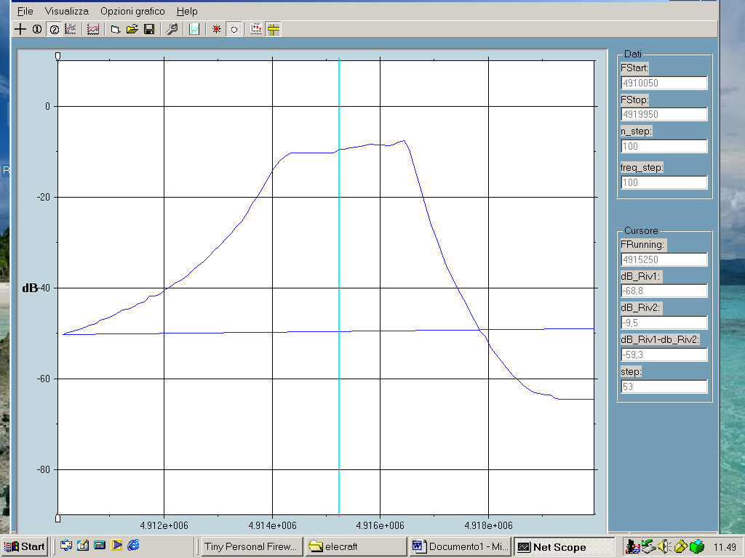N

This filter uses 4 x 4915 KHz Crystal

BFO position are the same as RX

On 20 m the side band supression can be estimated > 35 dB
On 40 m > 25 dB

NB: better results are obtained if the TX filter is equal to RX filter.

The filters plot are made with my network project:
Relevant informations to:
http://it.geocities.com/giulianoi0cg/digital_power_meter.html

For informations write to:
Giuliano I0CG
giulianori@libero.it
web page:
http://it.geocities.com/giulianoi0cg

