K1 RX SSB Modification
Here is explained the RX modification first; you can test it, then, if you like, you can increment modifications to add TX part also.

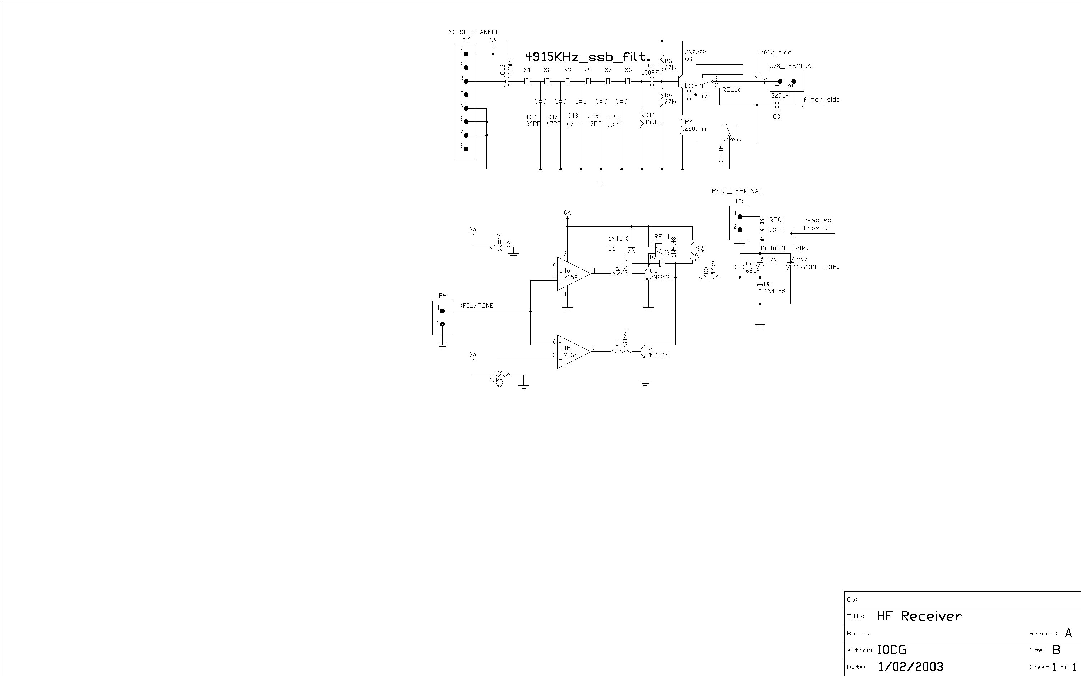
RF PCB preliminary mod.setup

On the K1 RF board the following components are removed:

R21, C38, RFC1

R21 must be removed to obtain a flat audio response on SSB. If R21 is not removed the audio response has optimized for CW (frequencyes higher then 1 KHz are cut off).

Added components:
Insert 4 female pins in place of C38 and RFC1.
Insert a female pin to have the XFILT/TONE signal available. This signal is on the PCB vias near the RF-P1 connector.
Insert Noise blanker connector (J1) ( 8 female pins connector)
To extend the K1 frequency range insert an NPO cap. 68 pF parallel to C2 (120 pF).
With this last mod. the frequency range is about 250 KHz (7-7250 and 14- 14250 KHz on my dual band K1)

This component change value:
C38 become 68 pF

To restore the normal K1 functionality you can fit C38 and RFC1 again on the female pins inserted on RF PCB.

SSB RX board construction

For only Rx mod a 50mm x 50mm (2 x 2 inches) board is necessary. For TX mod also a 50mm x 120 mm it is necessary.
The mod. board is plugged-in on the Noise-blanker connector and the others added pin. (no wires are added)

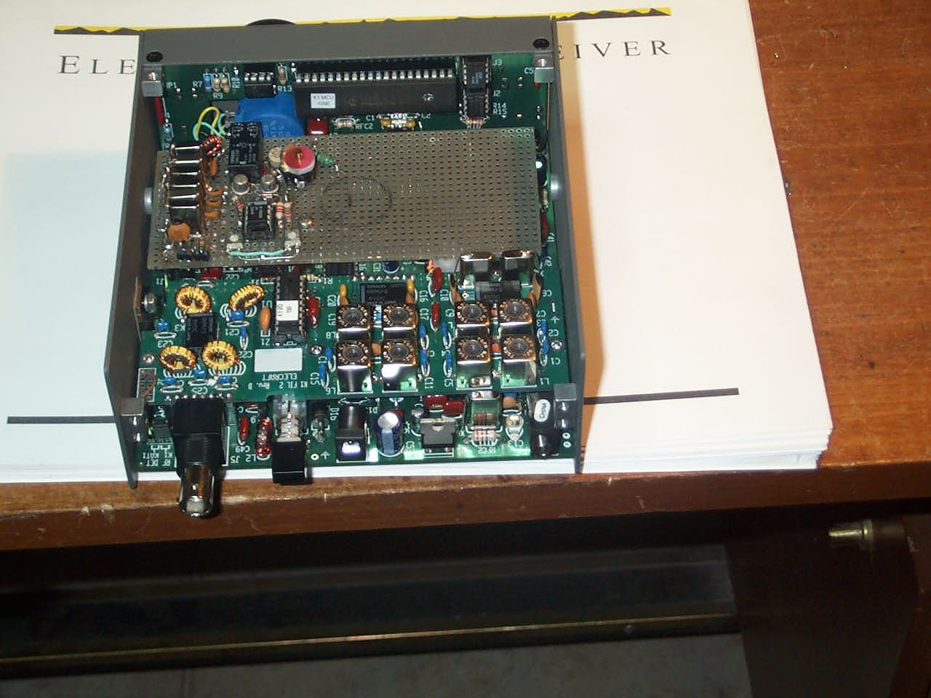

The prototype board (see the room space for TX mod also)

When the mod. is ready (see schematics and bill of materials) these Hardware SETUP are necessary:
Set V1 to 4.9 Vdc
Set V2 to 1.1 Vdc
Set filter 3 to 200 Hz (Fl3) then adjust C23 for 4916 KHz (USB)
Set filter 1 to 850 Hz (FL1) then adjust C22 for 4913 KHz (LSB )
Set filter 2 in the range 250 800 Hz to select the CW filter banduit
Verify that relay has switched on when FL1 and FL3 are selected.

Operation:
To set LSB mode press WPM+ and select FL1 (SSB filter and LSB frequency are selected)
To set USB mode press WPM+ and select FL3 (SSB filter and USB frequency are selected)
To set CW operation selected FL2
All 3 CW filters are availablle if are selected in the 250-800 Hz range. In this case SSB filter aren’t activated.

BILL OF MATERIALS
TYPE/VALUE QTY COMPONENT REFERENCE IDENTIFICATION
--------------------------------------------------------------------------------

68pF C 1 C12
220pF C 1 C9
2/20PF TRIM. C 1 C11
10-100PF TRIM. C 1 C10
33PF C 2 C4 C8
47PF C 3 C5 C6 C7
100PF C 1 C1
100PF C 1 C2
1kpF C 1 C3
1N4148 D 3 D1 D2 D3
SIP header 2-pin SIP2 3 P1 P3 P4
SIP header 8-pin SIP8 1 P2
2N2222 NPN 3 Q1 Q2 Q3
1500ohm R 1 R3
2.2kohm R 1 R8
2.2kohm R 1 R6
2.2kohm R 1 R5
2200 ohm R 1 R4
27kohm R 2 R1 R2
47kohm R 1 R7
Omron GBA 234p REL 1 REL2
33uH L 1 RFC1
LM358 LM358a 1 U1a
LM358 LM358b 1 U1b
10kohm V' 2 V1 V2
4.915MHz XTAL 6 X1 X2 X3 X4 X5 X6
K1 TX & RX SSB Modification
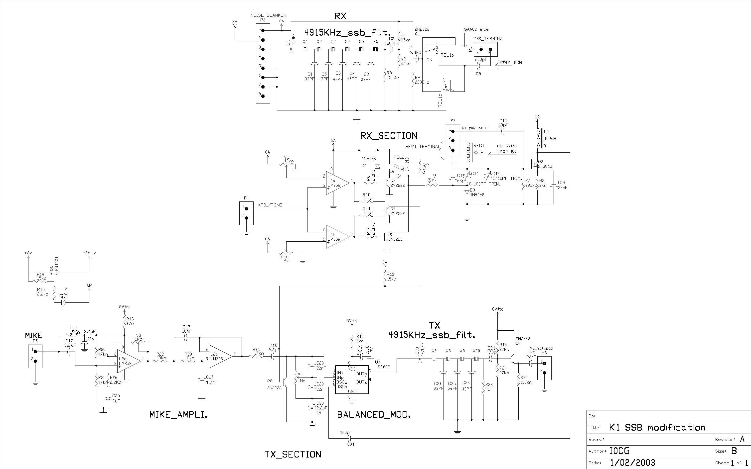
In the schematic the complete RX and TX SSB modification.
The RX SSB mod. is explained in the previous page; here are explained mod. to add the TX part.

K1 RF PCB mod.

Removed components:
- Remove X6
- RFC2 must be shorted

Added components:

- Add two female pins inside X6 quartz (to restore mod. X6 can be fitted on these pins)
- Add one female pins to have a 8V supply on the mod. board. (this supply voltage is available on a PCB via on front C18 K1 capacitor)
- same components can be inserted into RF board to change into Ab-class the final TX amplifier. (instead of class-C). This mod. is necessary to enanche the SSB quality.To add this mod. follows these steps:
- remove R31 and R32 from the GND connection (do not remove the Q7 base connection)
- add a standard diode (i.e.1N4148 ) in series to R31 , R32 .(catode to GND and anode to R31/32)
- polarize the diode via the 6T voltage (available on the R38/R28 terminals) through an 1K ohm resistor.
- Open terminal 4 of T3 from GND and connect it to the anode of diode.
- bypass the diode with a 0.1 capacitor

For more clarity see the following schematic of the performed mod. :

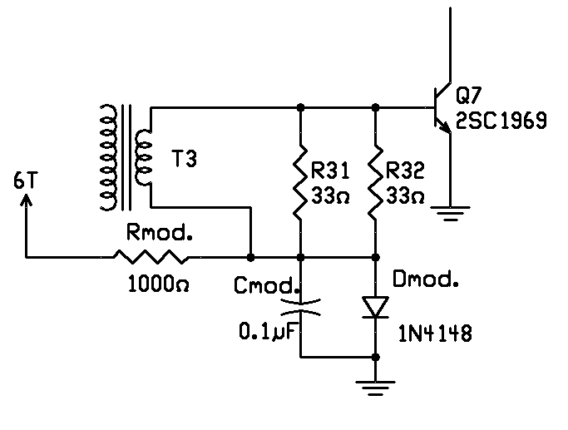
Class-AB mod

TX board construction:

For TX mod. a 50mm x 120 mm board is necessary.
See the overall TX and RX mod. schematics and relevant bill of materials.
The board is plugged-in on the Noise-blanker connector and the others added pin. (no wires are added)

OPERATION:
Reception:
To set LSB mode press WPM+ and select FL1 (SSB filter and LSB frequency are selected)
To set USB mode press WPM+ and select FL3 (SSB filter and USB frequency are selected)
To set CW operation selected FL2
All 3 CW filters are availablle if are selected in the 250-800 Hz range. In this case SSB filter aren’t activated.
SSB Transmission:
Transmission is performed using the TUNE Mode: press the WPM+ and WPM- simultaneously.
It is enough easy use this mode, especially if your thumb finger is enough large (HI !!).
CW transmission:
Any change on Cw trasmission is necessary. The SSB balanced modulator is unbalanced when the CW filter is selected.

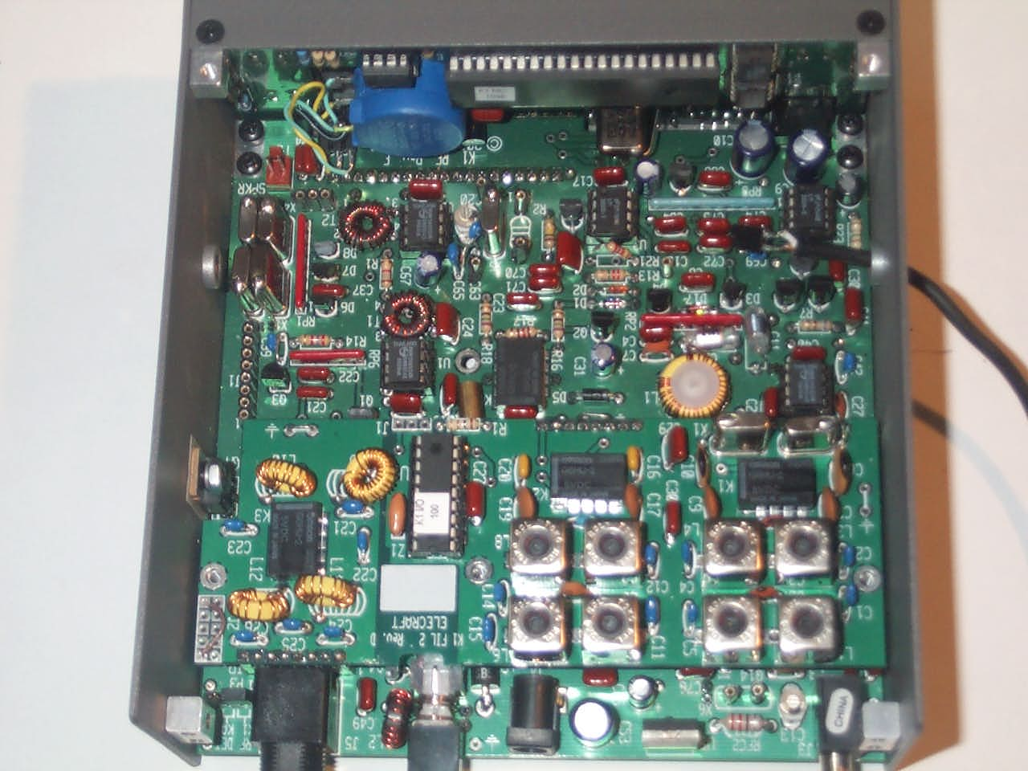
See the added modification pins
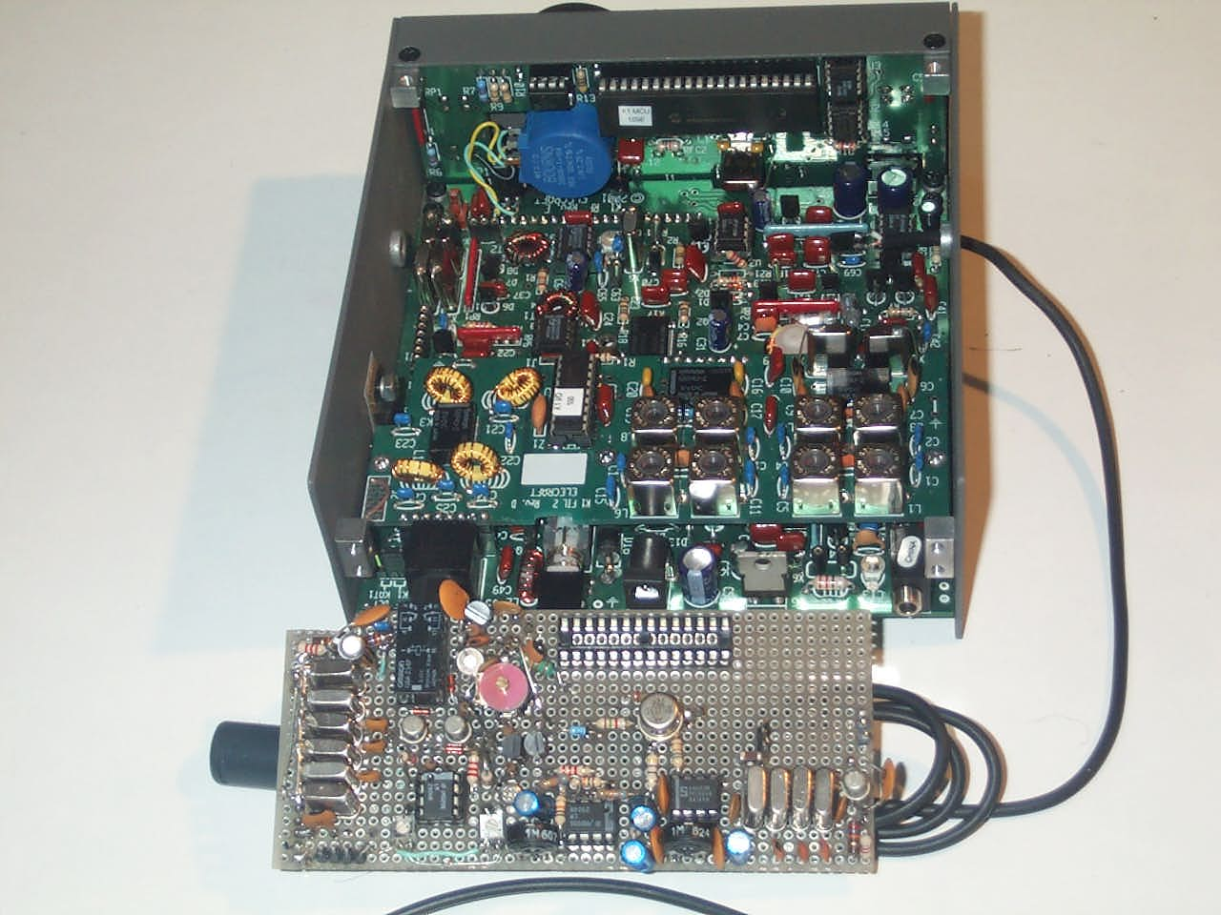
The complete prototype mod. extracted from K1.
The mike cable is inserted into a stand tilt hole.

BILL OF MATERIALS
TYPE/VALUE MODIFIER PATTERN QTY COMPONENT REFERENCE IDENTIFICATION
--------------------------------------------------------------------------------

2.2UF C 1 C29
33pF Cl 1 C10
68pF C 1 C13
220pF Cl 1 C9
470pF Cl 2 C21 C31
4.7nF C 1 C27
10nF Cl 1 C15
22nF C 3 C14 C23 C28
22nF Cl 1 C22
2.2æF C 1 C16
2.2æF Cl 2 C17 C18
2.2æF ?V CP 1 C19
1/10PF TRIM. C 1 C12
2.2uF ?V CP 1 C30
10-100PF TRIM. C 1 C11
33PF C 4 C4 C8 C24 C26
47PF C 3 C5 C6 C7
56PF C 1 C25
100PF C 1 C1
100PF Cl 1 C2
470PF C 1 C20
1kpF Cl 1 C3
1N4148 D 3 D1 D2 D3
100uH ? L 1 L1
SIP header 2-pin SIP2 4 P1 P4 P5 P6
SIP header 3-pin SIP3 1 P7
SIP header 8-pin SIP8 1 P2
2N1131 PNP 1 Q6
2N2222 NPN 6 Q1 Q3 Q4 Q5 Q7 Q8
2n3819 NCH 1 Q2
1500 ohm R 1 R28
47 ohm R 1 R16
1kohm R 1 R18
1500 ohm R 1 R3
2kohm R 1 R8

2.2Kohm R 1 R26
2.2kohm R 1 R12
2.2kohm R 3 R6 R15 R27
2.2kohm R' 1 R5
220 ohm R 1 R4
4.7kohm R' 1 R21
10kohm R' 2 R22 R23
15Kohm R' 1 R17
15kohm R 1 R13
15kohm R' 3 R10 R11 R14
27kohm R 4 R1 R2 R19 R24
47kohm R 3 R9 R20 R25
330kohm R 1 R7
REL 1 REL2
Omron GBA 234p TQ2 2 REL1a REL1b
33uH RFC L 1 RFC1
LM358 LM358a 2 U1a U2a
LM358 LM358b 2 U1b U2b
SA602 NE/SA602A SA602 1 U3
10kohm Pot V' 2 V1 V2
1Mohm Pot V 1 V4
1Mohm Pot V' 1 V3
4915 KHz XTAL 10 X1 X2 X3 X4 X5 X6
X7 X8 X9 X10
3.6 V Zener 1 Z1

Conclusion
- Operativity is’t changed when you use the K1 on CW.
- All 3 CW filters are avilable if you need it. (only 850 HZ and 200 Hz filters are lost).
- If you use CW, the power comsumption is about the same.
- If you use SSB reception power compsumption is about 35 mA higher.
- On transmission state the power compsuption is higher due to the class-AB polarization (about 100 mA higher)
- Mecanical mods are not necessary
- The K1 inital state is restored fast
With this modifications you can lose Elecraft Warranty. I have no responsability for any malfunction or damage caused by this mod.
This mod. is developped by: Giuliano I0CG .
e-mail giulianori@libero.it

Any update is available to this web address: http://it.geocities.com/giulianoi0cg

