K1 RX SSB Modification
Here has explained the RX modification first; you can test it, then, you increment modifications to add TX modification too.

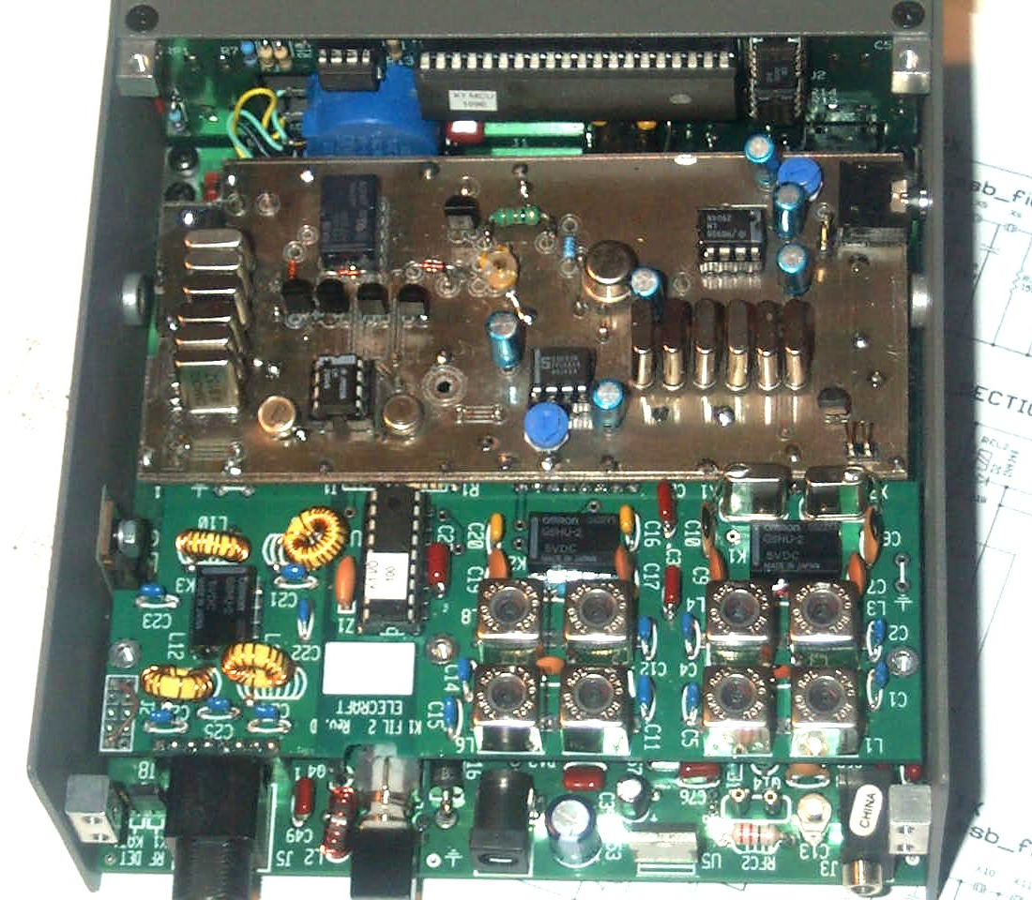
PCB protype board
Assembling RX part

RF PCB preliminary mod.setup

On the K1 RF board the following components are removed:

R21, C38, RFC1

R21 must be removed to obtain a flat audio response on SSB. If R21 is not removed the audio response has optimized for CW (frequencyes higher then 1 KHz are cut off).

Added components:
Insert 4 female pins in place of C38 and RFC1. (see RF PCB Photo in the following)
Insert a female pin to have the XFILT/TONE signal available. This signal is on the PCB vias near the RF-P1 connector.
Insert Noise blanker connector (J1) ( 8 female pins connector)
To extend the K1 frequency range insert an NPO cap. 68 pF parallel to C2 (120 pF).
With this last mod. the frequency range is about 250 KHz (7-7250 and 14- 14250 KHz on my dual band K1)

This component change value:
C38 become 100 pF

To restore the normal K1 functionality you can fit C38 and RFC1 again on the female pins inserted on RF PCB.

RX board assembling

Install all components of the RX section (see schematic and top layout). The SMD components in the bottom board are preasembled.

When ready, the SSB mod. board, is plugged in the Noise-blanker connector and the others added pin. (no wires are necessary)

RX Hardware SETUP
Set V1 to 4.9 Vdc (pin 2 of U1)
Set V2 to 1.1 Vdc (Pin 6 of U1)
Set filter 3 to 200 Hz (FL3) then adjust C12 for 4916.500 KHz (+/-100 Hz) for USB mod. (frequency test point on pin 6 of U3)
Set filter 1 to 850 Hz (FL1) verify 4913.500 KHz (+/-100Hz) for LSB mod. (frequency test point on pin 6 of U3)
With filter 2 ( FL2) adjust C34 for better CW note (about 4915.7 KHz)
Set filter 2 in the range 250 - 800 Hz to select the CW filter bandwidth preferred
Verify that relay has switched “on” when FL1 and FL3 are selected.

Operation:
To set LSB mode press WPM+ and select FL1 (SSB filter and LSB frequency are selected)
To set USB mode press WPM+ and select FL3 (SSB filter and USB frequency are selected)
To set CW operation selected FL2
All 3 CW filters are availablle if are selected in the 250-800 Hz range. In this case SSB filter are not activated.

Assembling TX part.
K1 RF PCB modification
Removed components:

- Remove X6
- RFC2 must be shorted

Added components:

- Add two female pins inside X6 quartz (to restore mod. X6 can be fitted on these pins)
- Add one female pins to have a 8V supply on the mod. board. (this supply voltage is available on a PCB via on front C18 K1 capacitor)
- same components can be inserted into RF board to change into Ab-class the final TX amplifier. (instead of class-C). This mod. is necessary to enanche the SSB quality.To add this mod. follows these steps:
- remove R31 and R32 from the GND connection (do not remove the Q7 base connection)
- add a standard diode (i.e.1N4148 ) in series to R31 , R32 .(catode to GND and anode to R31/32)
- polarize the diode via the 6T voltage (available on the R38/R28 terminals) through an 1K ohm resistor.
- Open terminal 4 of T3 from GND and connect it to the anode of diode.
- bypass the diode with a 0.1 capacitor

For more clarity see the following schematic of the performed mod. :

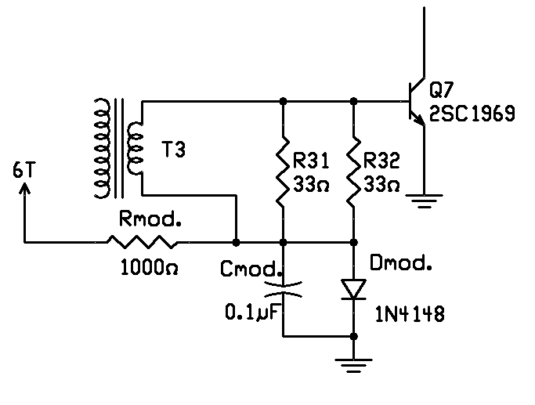

Class-AB mod

TX board assembling:

See the overall TX and RX mod. schematics and relevant bill of materials.
As RX part only the top board components must be assembled. (surface components are pre-assembled)
The board is plugged-in on the Noise-blanker connector and the others added pin.
A shield cable (2” length) must be connected from 2 pin connector P6 and the pin added on X6 place

TX Hardware SETUP
Select K1 filter 1 or 3 then go in TX mode ( see below) then adjust V4 Pot. for maximum carrier suppression (you can use a Scope or another receiver)
Insert mike then adjust V3 pot. for suitable mike sensitivity.

OPERATION:
Reception:
To set LSB mode press WPM+ and select FL1 (SSB filter and LSB frequency are selected)
To set USB mode press WPM+ and select FL3 (SSB filter and USB frequency are selected)
To set CW operation selected FL2
All 3 CW filters are availablle if are selected in the 250-800 Hz range. In this case SSB filter aren’t activated.
Transmission:
Transmission is performed using the TUNE Mode: press the WPM+ and WPM- simultaneously.
To return on RX press any key.

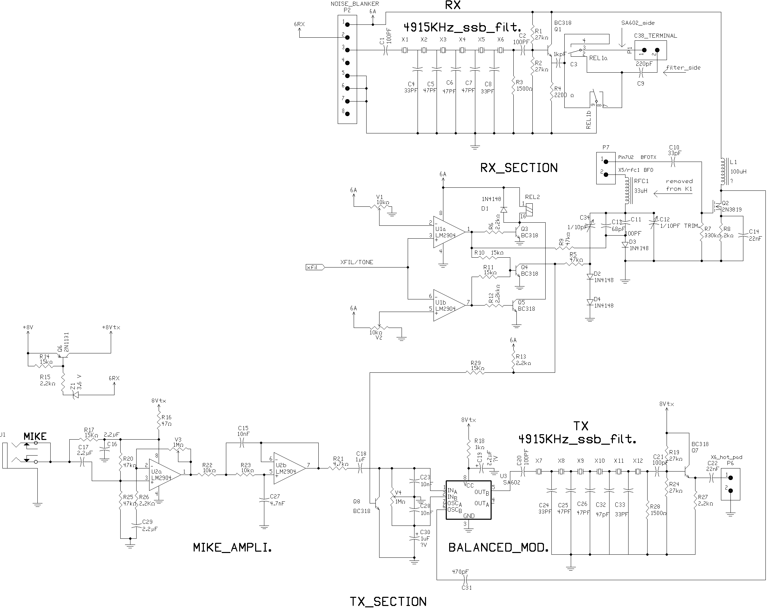
Schematic of RX and TX SSB modification.

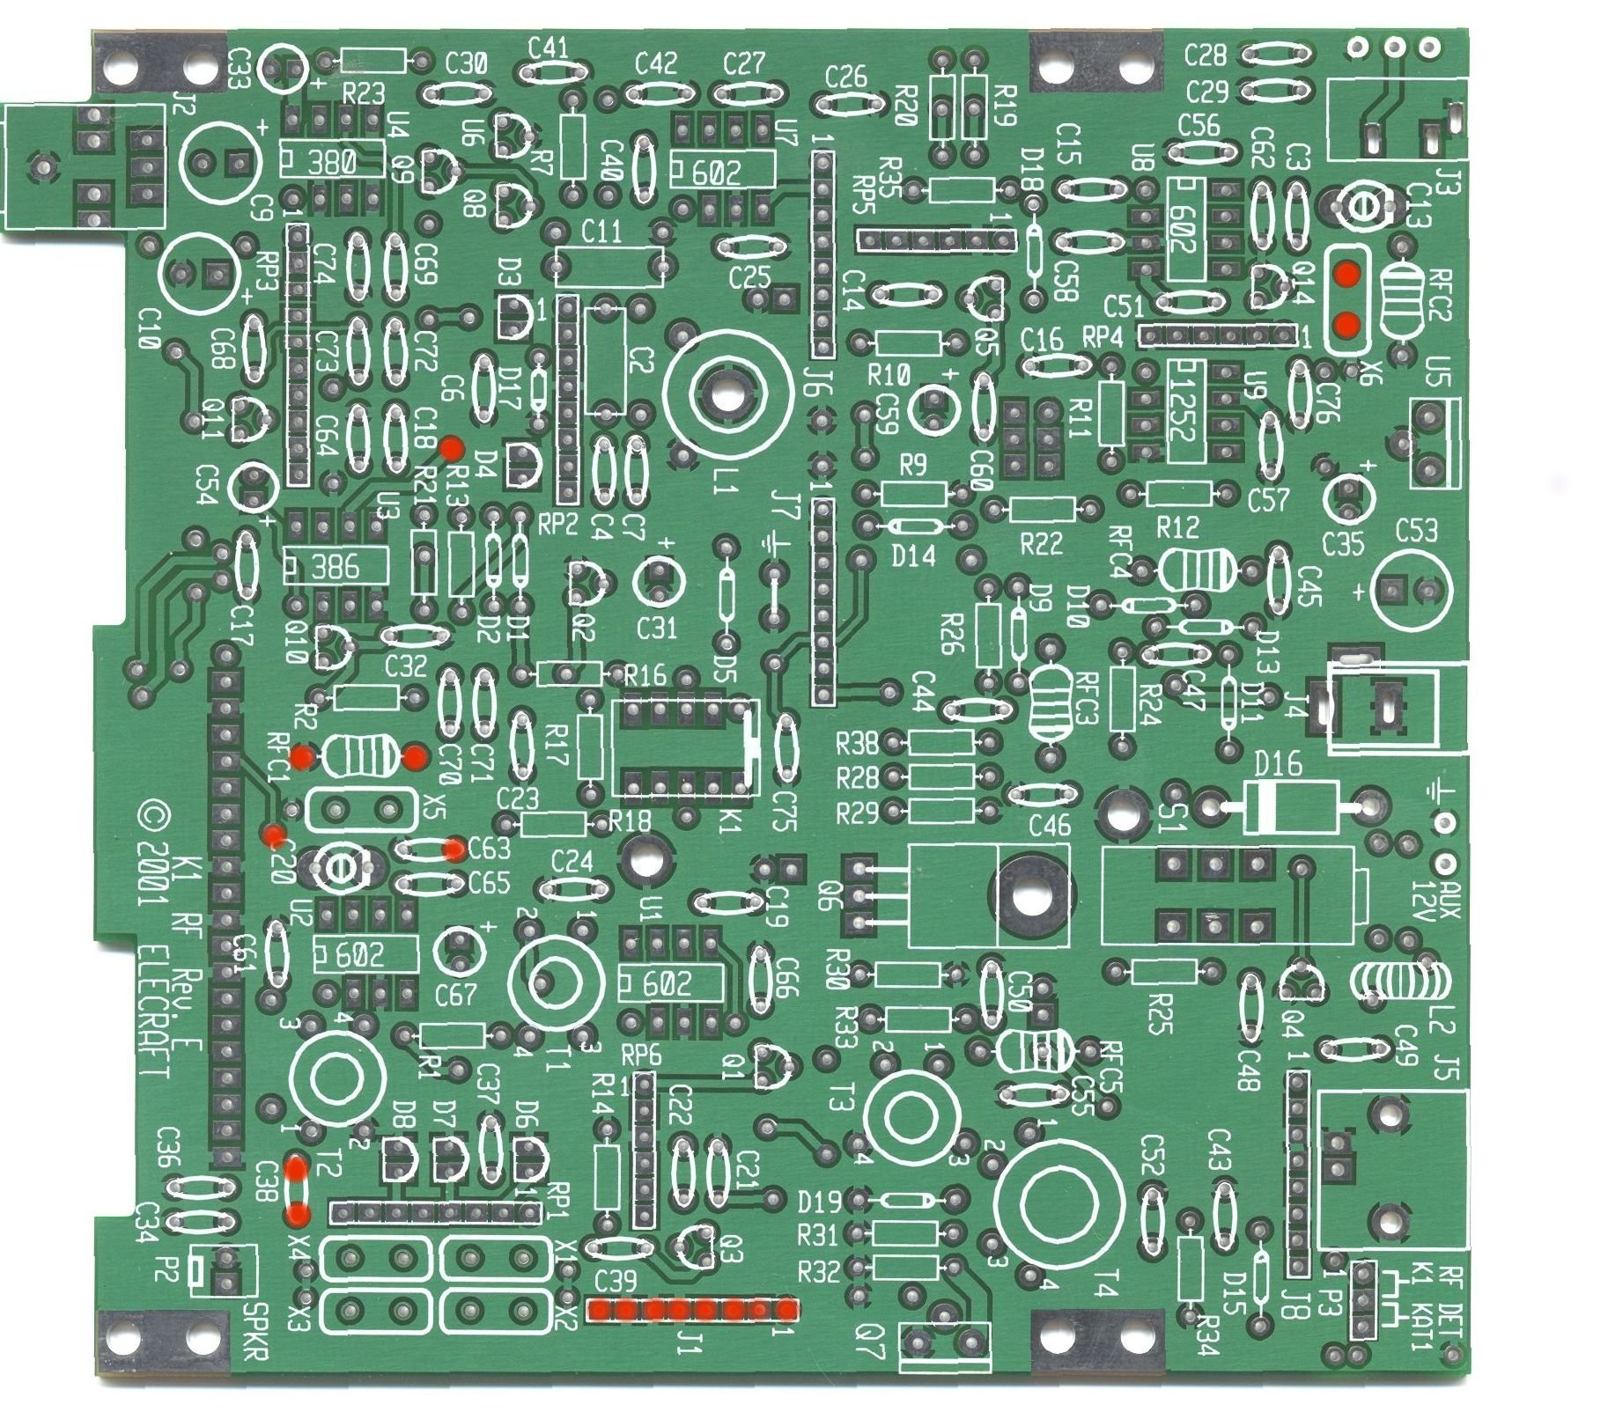
The red points shows female pins added on the K1 RF PCB
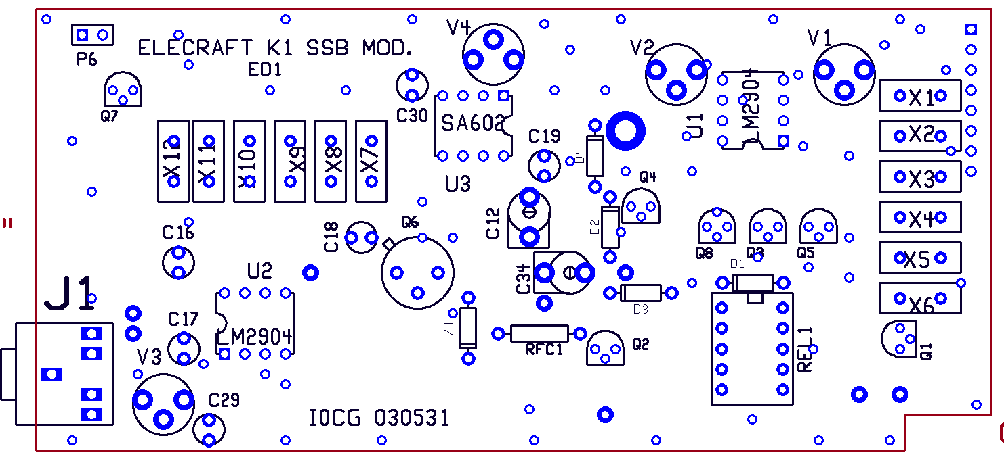

Top layout
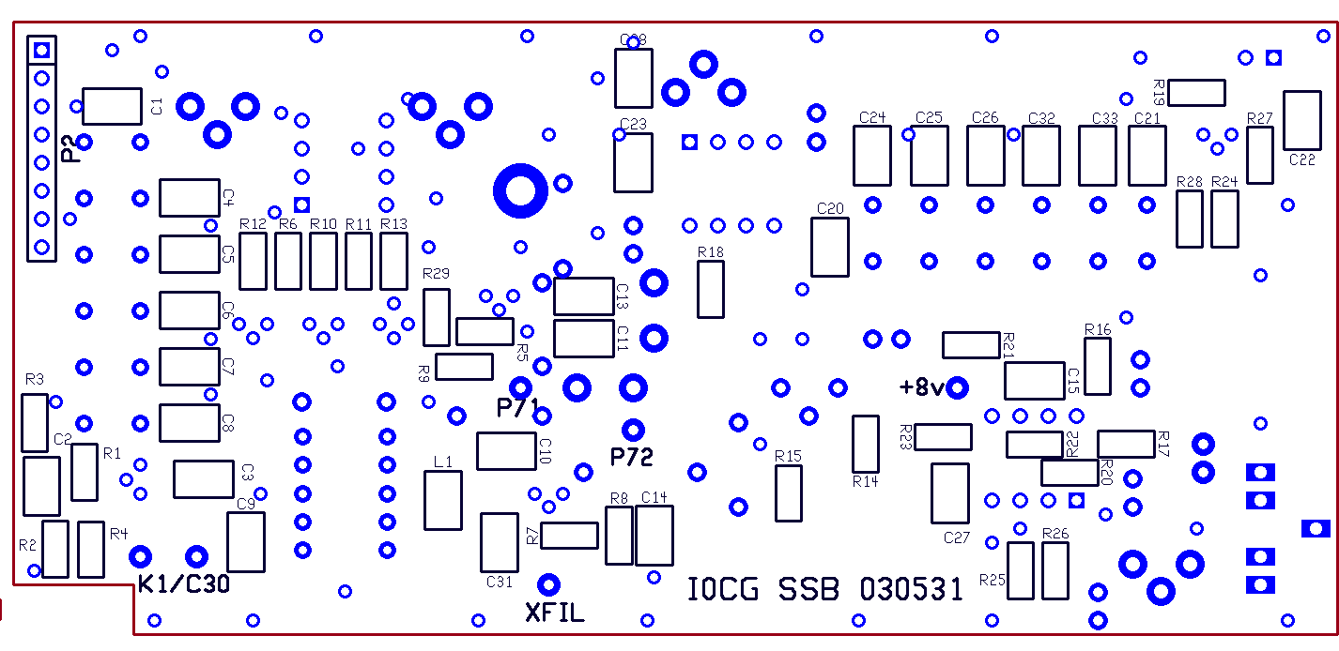

Bottom layout . The SMD components are pre-assembled

On this side install only the following components:

8 pin connector P2
2 pin connector K1/c30
1 pin connector XFIL
1 pin connector P7_1
1 pin connector P7_2
1 pin connector +8V

Bill of materials

NAME VALUE

C1 100PF
C2 100PF
C3 1kpF
C4 33PF
C5 47PF
C6 47PF
C7 47PF
C8 33PF
C9 220pF
C10 33pF
C11 100PF
C12 1/10PF TRIM.
C13 68pF
C14 2nF
C15 10nF
C16 2.2UF
C17 2.2UF
C18 1UF
C19 2.2UF 15V
C20 100PF
C21 100pF
C22 22nF
C23 10nF
C24 33PF
C25 47PF
C26 47PF
C27 4.7nF
C28 10nF
C29 2.2UF
C30 1uF 15V
C31 470pF
C32 47pF 15V
C33 33PF 15V
C34 1/10pF
D1 1N4148
D2 1N4148
D3 1N4148
D4 1N4148
J1 NC/3-Ckt
L1 100uH
P1 2-pin
P2 8-pin
P6 2-pin
P7 2-pin
Q1 BC318
Q2 2N3819
Q3 BC318
Q4 BC318
Q5 BC318
Q6 2N1131
Q7 BC318
Q8 BC318
R1 0 27k OHM
R2 27k OHM
R3 1500 OHM
R4 2200 OHM
R5 47k OHM
R6 2.2k OHM
R7 330k OHM
R8 2k OHM
R9 47k OHM
R10 15k OHM
R11 15k OHM
R12 2.2k OHM
R13 2.2k OHM
R14 15k OHM
R15 2.2k OHM
R16 47 OHM
R17 15K OHM
R18 1k OHM
R19 27k OHM
R20 47k OHM
R21 4.7k OHM
R22 10k OHM
R23 10k OHM
R24 27k OHM
R25 47k OHM
R26 2.2K OHM
R27 2.2k OHM
R28 1500 OHM
R29 15K OHM
REL1 TF2-5V NAIS

RFC1
U1a LM2904
U1b LM2904
U2a LM2904
U2b LM2904
U3 SA602
V1 10k OHM Pot
V2 10k OHM Pot
V3 1M OHM Pot
V4 1M OHM Pot
X1 XTAL 4915KHz
X2 XTAL 4915KHz
X3 XTAL 4915KHz
X4 XTAL 4915KHz
X5 XTAL 4915KHz
X6 XTAL 4915KHz
X7 XTAL 4915KHz
X8 XTAL 4915KHz
X9 XTAL 4915KHz
X10 XTAL 4915KHz
X11 XTAL 4915KHz
X12 XTAL 4915KHz
Z1 Zener 3.6 V

